How Do I(We) Get To Camp Arrowhead?
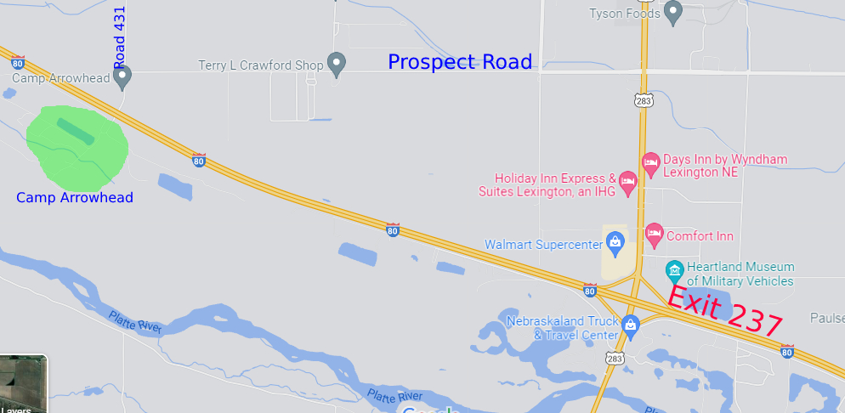
DIRECTIONS:
**ADDRESS: 75352 Road 431, Lexington, NE 68850
**CAMP PHONE: 308-324-1956 or Pastor Hubert’s Phone: 740-817-0585
From I-80(East~Ogallala/North Platte or West~Omaha/Lincoln)
Exit 237 at Lexington, go North.
Travel North on Hwy 283 for 1 mile to second Stop Light at W. Prospect Road.
Turn Left (West) on Prospect Rd. and travel 2 ½ miles to “T” in the road – Road 431.
Turn Left (South) on Road 431 and follow going over I-80 to the “T”.
Turn Right and an immediate Left.
Follow road into Camp Gate.
When You/Your Group Arrive at Camp:
Please Check-In On-Site at the Open Air Pavilion.
**Remember, there will be NO On-Site Registration!**

